EC5070: DATABASE SYSTEMS

LAB 03

BANDARA H.G.T.D.

2022/E/048

SEMESTER 05

23 MAY 2025

***TASK 01:***

Implement the Edit and Delete functions and complete this project part of the Course Management System.

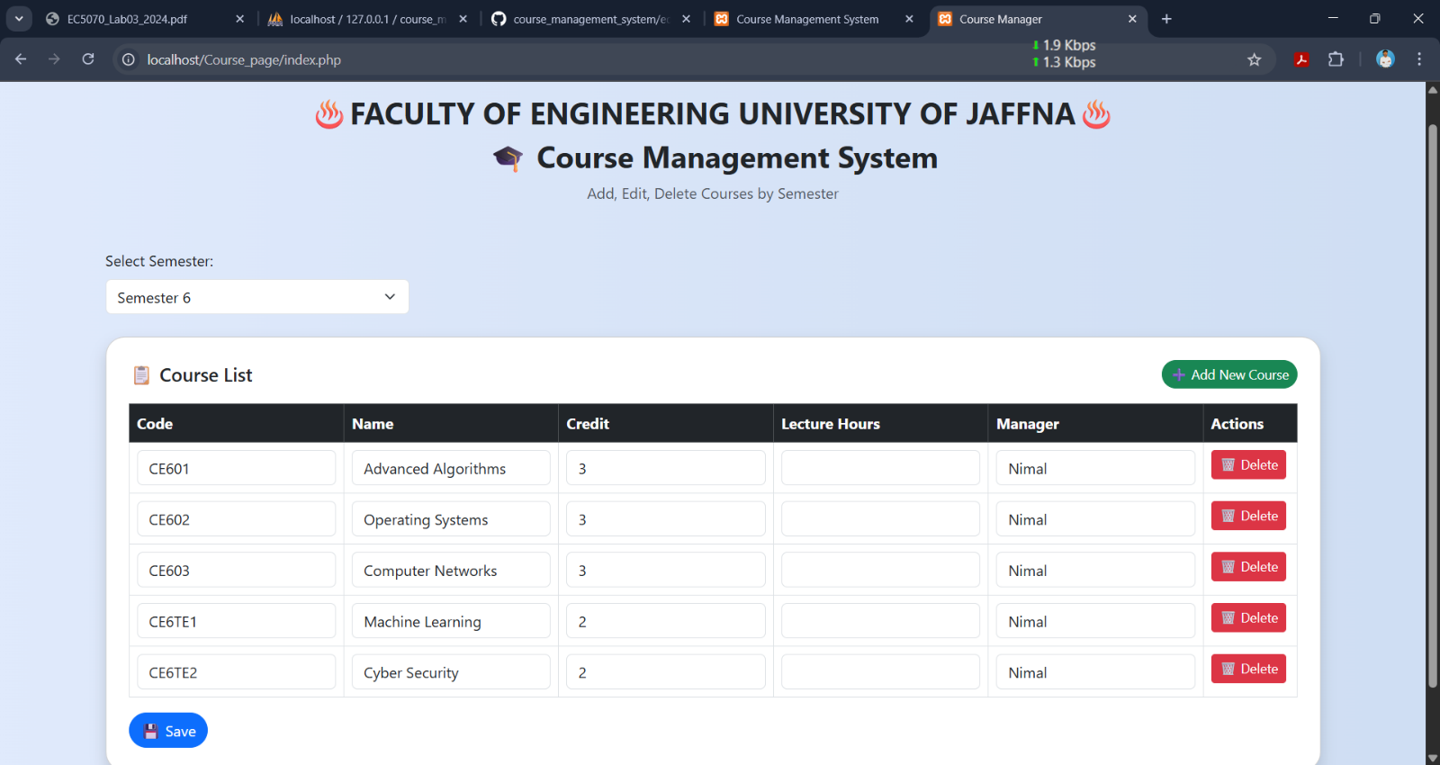

FIGURE 1: EDIT & DELETE

***TASK 02:***

Function/procedure calls

1. Implement the query in command line (to insert 5 courses of sixth semester (consider Department of Computer Engineering only). Two of them should be technical electives with 2 credits. Others core courses with 3 credits. Leave the hours as NULL.

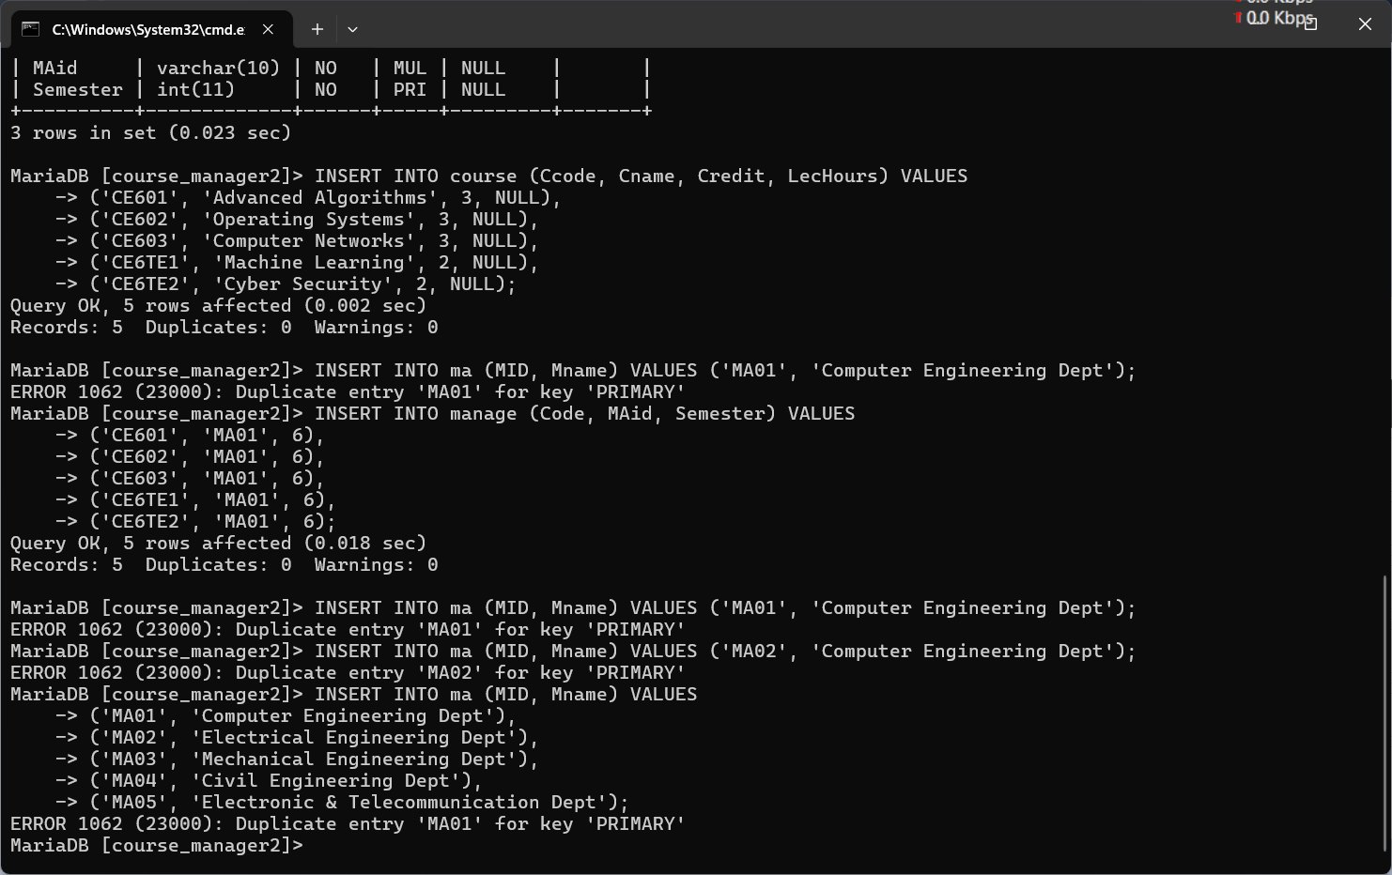

FIGURE 2: DATA INSER TO COURSE TABLE

FIGURE 3: DATA INSER TO MA TABLE



FIGURE 4: DATA INSER TO MANAGE TABLE

2. Modify the Hours column with 30 hrs for the technical electives and 45 hrs for the core modules using MySQL stored procedure within PHP pages (not through command line).

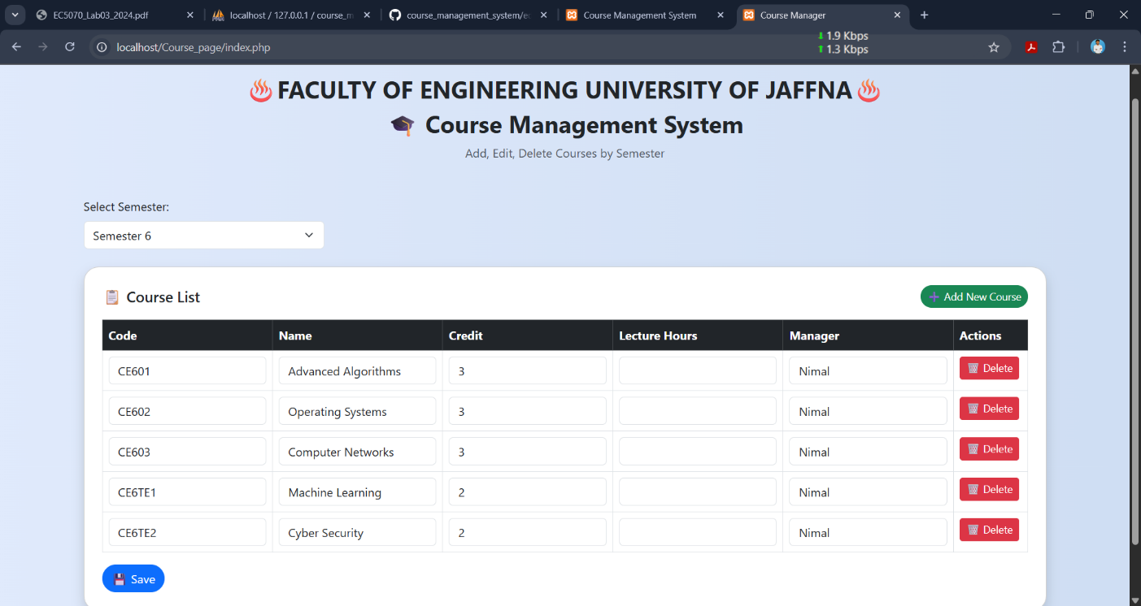

FIGURE 5: BEFORE EDIT LECTURE HOUR FIELD AS 45

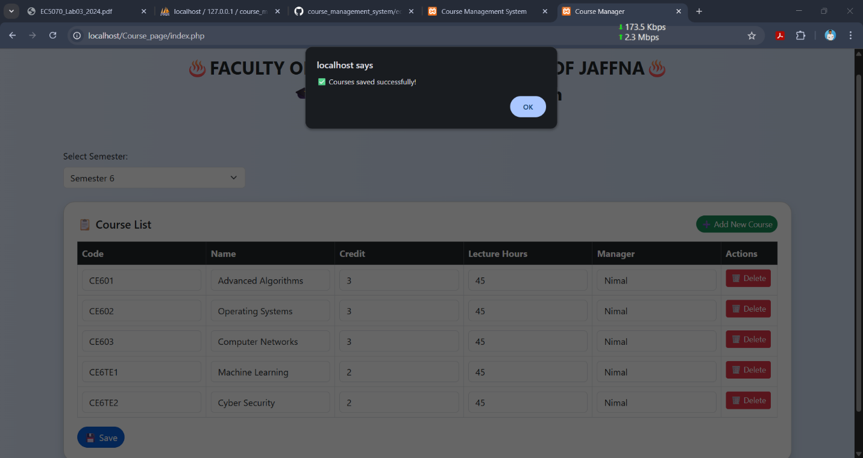

FIGURE 6: AFTER SUCCESSFULLY EDIT LECTURE HOUR FIELD AS 45

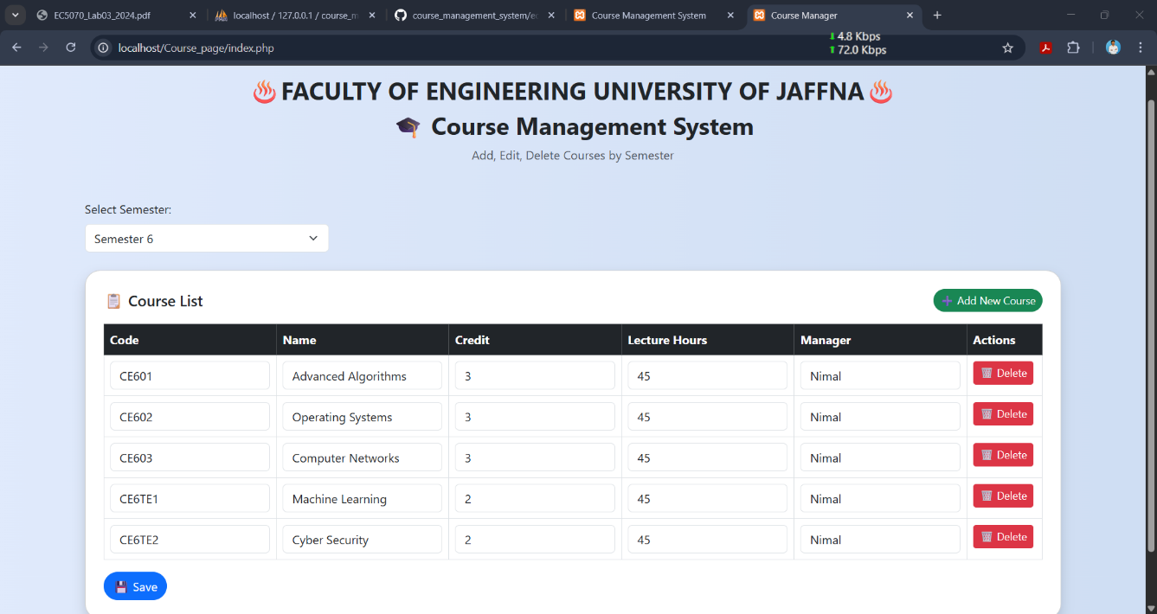

FIGURE 7: AFTER EDIT ALL LECTURE HOUR FIELDS